# Cover Page

# Background Information

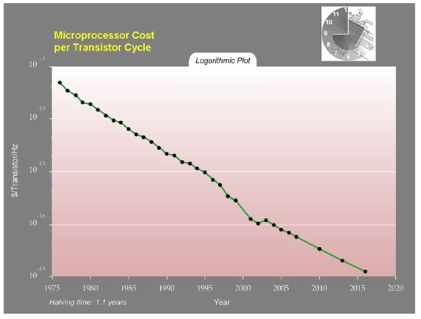

Ever since the decline of price in complex fast microprocessors, the world of automation has been a popular hobby among electronic enthusiasts. With the introduction of the Internet, these automation hobbyists began to automate their own home by using a system of networks, inspired by the Internet. As of recent (2005) a huge increase in the popularity of home automation system as seen its way into the commercial market with houses been built using an automated appliances infrastructure. In 2008, Clipsal filed their first patent for the C-Bus technology, titled “Method for optimising return results of CBUS server and CBUS server”. This was the basis that C-Bus technology was built on and what made it stand out from similar products. Ever since I was young I have been intrigued by the inner workings of CBUS, and have drawn lots of inspiration. I plan on using this inspiration to complete my MDP.

# Project Proposal

## Identification and exploration of the need

As someone who frequently visits my grandmother’s house, I have noticed a few things that operate differently and undesirably due to unfortunate circumstances. Some of these functions that are not used to their full potential are often hearing and remembering functions, for example a door bell or a fire alarm audible alert not being heard, or forgetting to take medications. This is an obvious flaw in the environment of an elderly person, especially with rates of hearing impairment at 5.7% for the population as a whole, with rates for the elderly almost 10x <> that amount.

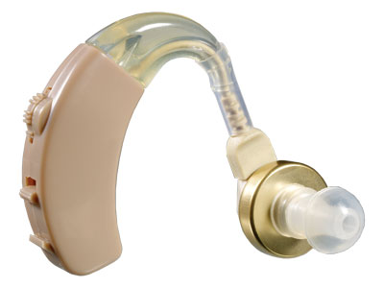

Many times have I been at my nans house when a doorbell or medicine alarm has gone off and she has completely unawarely ignored it. This greatly bothered me, and after asking my Grandmother it too greatly bothered her. We had a need <>.

I decided to setup a mini test to see how a different type of alert would help my Grandmother notice what is happening. The test was conducted informally where I told her that if the lights go very dim, full brightness, very dim, then back to full brightness there would be someone at the door, but if the light dimmed once and went back to normal brightness that it was time for her to take her medication. I spent the next 3 days at hers acting casual as she was possibly waiting for me to give this visual alert, but for the first 2 days I did not. It was on the third day that I tested this alert by signifying the doorbell using the light dimmer, and immediately my Grandmother smiled and opened the door.

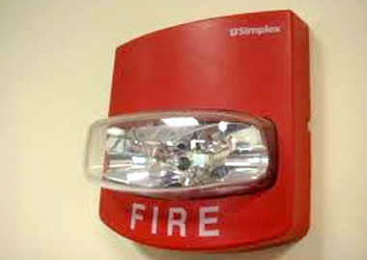

My Grandmother was very pleased with this idea of a visual alert over an audible alert and was happy to supply me with another idea for it, and that was to possibly have a visual alert for the fire alarm.

I later setup various interviews with my grandparent’s friends who they knew had a hearing impairment. I asked them a few simple question to really see if there was a need for my product:

|  |  |  |  |
| --- | --- | --- | --- |
| Question | Reason for Question | Yes | No |
| Are you hearing impaired in any way? | To see if the participant is part of my target market | 10 | 0 |
| Do you ever find that you have missed someone at the door due to not hearing the doorbell? | To see to what extent their impairment is, and again, whether they are part of this target market. | 8 | 2 |
| Do you ever find you forget about your medication and/or not hear an alert for when to take them? | To see to what extent their impairment is, and again, whether they are part of this target market. | 9 | 1 |
| Would you be interested in a visual alert for these other alerts you are missing (not applicable to those who answered no to both Q2 and Q3) | To see if there is interest for my product in this market. | 8 | 1 |

I then asked “How would you like to see this visual alert?” to the 8 who answered yes to Q4. Out of 8 people, 2 gave quality answers:

* “I would like to my lights change colour. Say, green for the doorbell and red for the fire alarm. I just don’t want anything too flashy though due to my epilepsy”
* “Hmm, I think if the light were to dim in a pattern when the doorbell rang that would be great. Even if they are off, if they could come on full then dim back down I think I could know if someone was at the door”

By combining these two ideas, I came up with a solution to the problem. If I could have red, green, blue and white lights that fade their brightness in a certain pattern, signifying an event, then this product could become a need for this market.

|  |  |
| --- | --- |
| Need Analysis – From my initial investigations | |
| What type of need has been identified? | Something that is going to give a visual alert for those who can not heard audible alerts. |
| Who is my target market? | My current target market is those with hearing impairments. |
| What do they want my product to do? | They want my product to be a cheap solution to allow them to visually see alerts that would normally be only audibly noticed. |
| How do existing products fall short of providing for this need? | Existing product have fallen short of this need such as hearing aids which do not cater for the entire market and are often not worn when the need is present. |
| What demographic features identify this group? | The main demographic is the elderly who have hearing impairments, but this could extend to anyone who has a hearing impairment or even someone who prefers a visual alert over an audible one. |
| What could I do to expand my target market? | I could expand my target market but adding extra features onto this visual alert system. A line must be drawn though, as successful products do not attempt to fill too many target markets needs. |
| Can I produce a product which is both desirable to the target market and economically viable? | Yes, this is a main factor that I am trying to meet with my product. It should be economically viable through the use of high quality yet low cost materials. |

## Design Proposal

Many new innovations come out today and revolutionise the way lives work in the world for most of the population. But what about that other bit of the population, the elderly? My design proposes to give the elder demographic a higher quality of life, by meeting a few crucial needs of the target market. These needs are:

* Missing alerts due to being hearing impaired
* Struggling to turn off lights due to aching pains
* Forgetting to turn off lights when going out
* Concerned about high costing electricity bills each month
* Light is too bright for comfort
* Light is not the right colour to concentrate

All of the needs will be fulfilled with my design, of the Light++.

## Preliminary Research

I have already completed preliminary research on all of the needs, to ensure they are real needs and not just charlatan needs.

* Missing alerts due to being hearing impaired: In 1993, the Australian Bureau of Statistics compiled the number of those with a disability, which was 18.1% of the population. Of this number, 31.5% had a hearing impairment. This equates to 5.7% of Australia’s population having a disability. This justifies the need for a visual stimulus rather than an auditory stimulus to be produced when an alert is activated.
* Struggling to turn off lights due to aching pains

With the common uptake of home automation, many implication arise such as the ecological, economical, social, ethical, and legal factors which can implicate the design process. With the implicating factors, a designer must come up with a solution to go around the problem or fix the problem entirely. A designer has failed when the implication has no solution, and the uptake of the product will not be as great as it would be if the implication had a solution.

Ecological:

• Name and Define: Ecology is relating to or concerned with the relation of living organisms to one another and to their physical surroundings. This fits in with home automation in terms of the pollution the product gives off, and the cradle to cradle life cycle of the product.

• Describe: One of the main advantages of purchasing a home automation system is the aspect of saving the environment through the limiting of electricity usage. Home automation systems strive to achieve this goal by having timers behind most electrical appliances which automatically turn them off after a certain period of time, or a certain period of time when not in use. Another aspect of ecology in home automation is the cradle to cradle life cycle of the product. Most home automation products do not have any information on how their products are environmentally friendly in this respect, so it may be expected they are not the most recyclable.

• Explain: Through the use of these automatic timers that can turn off appliances, electricity can be saved. According to studies conducted by many parties, 41% of Australians keep lights on which are not in use <http://www.news.com.au/finance/money/complacent-australians-wasting-millions-of-dollars-on-energy-bills/story-fnagkbpv-1226766375012>.By saving electricity, we can reduce the amount of CO2 that is going into our atmosphere which is a leading contributor to global warming. Another positive behind the use of automation to turn unused lights off is reducing light pollution in communities where seeing the night sky is not possible. We should be wary about the materials used to build these products, as they do not provide profiles for how environmentally friendly these systems are, and it might not be environmentally friendly, even if lots of electricity is saved.

• Analyse: Implications that might arise from attempting to be environmentally friendly with such home automation systems is the process of installation. Although many users may think they are caring for the environment, they may make more pollution or waste through installation than what they will save with the product.

• Critical Evaluation: In total, if you are looking for a product that is good for the environment, this may be the product you are looking for, depending on various elements. Such elements can be the type of home automation you are installing and ensuring that the product has an environmentally friendly material profile, and when installation of the products occurring. It would be best for the environment if this system/product were to be setup during the building and wiring stage of the house. This ensures that there is no wasted materials as installation into a built house would require disposal of old parts and tear down of some walls.

Economical:

• Name and Define: Economics in relation to home automation is the amount of money that will be spent, saved, or lost when purchasing or not purchasing a home automation system.

• Describe: A common aspect of home automation is the consideration of the amount of money that can potentially be saved in electricity costs when automation is used to turn off appliances. A factor to consider when calculating the electricity saved by automatically turning off appliances is the electricity needed to run this automatic system. This is almost always accounted for though when the system is hooked up to two lights or more. Another factor is that although you will certainly save money in the electricity bill, it may cost more to purchase this product and install it. Alongside this, as technology is always advancing, will this product become obsolete in the near future, or will it adopt to a set of standards?

• Explain: When calculating the savings made with a home automation system, it is not as simple as looking at your electricity bill and observing the lower number. It is a more complex formula that must involve the price of the product, the price of installation, time until obsolescence, and maintenance.

• Analyse: Implications may occur when using this product, so it is essential that upfront costs and maintenance are factored into the calculation of the economic benefit of the system. For instance, a family’s electricity bill may be reduced by $500 a year by using home automation. However, if the system costs $1000 to buy and install it will take 2 years for the system to pay for itself, and if the system costs money to maintain, the payback period would be even longer. In some cases the payback period may be too long to justify the system or the annual savings may not be enough to cover maintenance costs.

• Critical Evaluation: Before installing the system an objective cost benefit analysis should be carried out. A scenario that could save money would be where a family of 5 are planning on building a new, large home. They can install this product as they build the house, reducing the cost of installation. As the house is very large, many redundant lights may be accidentally kept on, costing the family lots of money in electricity. But because of the home automation system, these lights automatically turn off, saving the family from wasting money. A scenario in which home automation would not suit would be a small house that houses less than 3 people that has already been built.

Social:

• Name and Define: Social means the interaction and relationship between living organisms. Social implications may arise when dealing with home automation systems, such as social status and trust issues when it comes to automated security.

• Explain: Although not that expensive, home automation systems can be perceived as expensive toys for rich people. By installing a home automation system, people around yummy become jealous and start to think you are trying to reach a higher social status by throwing money away. Another social implication could be when one of your friends come over and you are trying to secretly enter your doors security code. Your friend may feel unsettled by this, and assure you do not trust him/her.

• Analyse: Unfortunately, the air surrounding home automation is that of a pretentious rich man, and installation may have negative connotations through social status with your friends. It's not until the product hits a more popular mainstream commercial setting that the social status behind home automation will lessen. The implication that arises through the use of home automation systems that take security measures, is that of trust. For example if Yehuda a keypad on your door that unlocked it, and you had a friend with you, do you try to hide your pin and potentially hurt your relationship or do you naturally enter your code in front of your friend, and thereby potentially threaten the security of your house.

• Critical Evaluation: Using the above information I think the benefit of having an automated house is above that of the issues previously raised, but as time goes on this will not be as much as a problem with uptake of this innovation. In regards to trusting your friends with the pin to your house, I think a design innovation could overcome this issue. Combining a key lock and a number lock together where you could use either to open the door would allow for a better system.

Ethical:

• Name and Define: Ethical behaviour can be simply defined as not taking unfair advantage of someone or something. Such ethical implication that may arise from home automation are would electricity companies try to prevent this product from becoming publicly available, and the potential monitoring of your house by a company.

• Explain: Because of the electricity that could potentially be saved, this innovation would be negative for electricity companies who are trying to sell you the electricity. These companies may buy the innovations rights and keep them for themselves to protect their profits. This is an unethical act to do that does not benefit anyone but the companies. Another ethical implication is the monitoring and or spying of home automation companies. For example, how would you feel if you were on holidays and got a call from the company saying tattoo had left your TV on? This is a major ethical implication that cannot easily be resolved.

• Analyse: The implication of an electricity company buying this technology is a major concern. Let's assume with home automation you could save 25% off of your electricity bill. This equates to exactly a 25% loss for the electricity company, which could ruin their business. In 2013 Energy Australia’s total revenue was $8,843,050,000<http://www.ibisworld.com.au/car/default.aspx?entid=11758>, if we take 25% of that number that equals roughly 2 billion dollars. Seeing these statistics, the innovator would make much more money by selling the innovation to Energy Australia, than selling it to the Australian public. The other ethical implication of concern is the use of these automation systems to unethically monitor and or spy on the users. A simple 'Band-Aid' solution to this problem would be to not have an overall monitoring system, and just let the user monitor it themselves. But this does not fully cover the implication as many users are too busy to monitor the system or may not have the understanding to monitor it themselves.

• Critical Evaluation: Concluding from the above information, an innovator would do much better selling the idea of the innovation to electricity companies rather than designing the product and selling it to the Australian public. But, another designer may design a similar product that is not breaching copyright law and could therefore still sell systems to the Australian public. With the idea of these automation system companies monitoring your house hold, it may only be wise to purchase the system if you have the required knowledge to monitor the system yourself instead of the company. This means they cannot spy on you, and your system is fully functional still. If you do not mind a company monitoring your household though, you may be fine with a limited understanding of this product and be able to use it to its full potential.

Legal:

• Name and Define: Legal can simply be defined as the rules and regulations that govern how things should occur. As home automation is a relatively new innovation, there are still grey areas for what is legal and illegal. From these grey areas, implications can arise, such as the level of access companies have with these automation systems, and potential monopolies on the installation and maintenance of the system.

• Explain: Legal implications arise due to the grey area of the current laws surrounding home automation. Do companies have full access to these systems, opening a way for them to collect data about you, or is there a law in place to stop this? Well, due to it being a grey area, there isn't a clear answer, possibly allowing company’s unlimited access to your automation system. Another implication may be the installation of such a system. Although the process may be easy for some, you will probably need to get the relevant licensed tradesperson to install it and certify its safety.

• Analyse: As home automation picks up in popularity, so will the amount of laws created to protect the user of such systems. It may be safe to wait until the law on home automation is black and white, rather than a grey area before installing. One of my main concerns is the implication of installation. With current households, most things more than replacing a light bulb require a certified tradesmen to do it for you. The home automation company may try to get a special license that is required to be able to install such a system, limiting the amount of tradesmen that can complete the installation to very few. The company could also make the tradesmen charge a very high installation fee, in attempts to get more money out of the customer.

• Critical Evaluation: Due to this grey area of laws, it might be best to wait until a better system of laws regarding this innovation is put into place. If you are not concerned though with companies collecting your data or potentially spying on you, there is no need to wait, as these are the only legal implications which are in the grey area. To the second implication, it would be best to check with the company about installation procedures before purchasing. If the company says they you need a special type of tradesmen, check first how much this would cost. If it's obvious they are over charging, look at a different company’s product.

## Analysis of Research

## Justification of Need

After establishing that there is indeed a market for this product, I have to evaluate my findings and ask myself why I am doing this product. A good criteria to evaluate the justification of a need is to have a rational scenario, mimicking scenario, regulations scenario, and a standards scenario.

* Rational Scenario: This is the action of looking at hard facts and numbers to see if they need can be justified through logic. Rational scenarios do not take into account ethics or legalities, but nor does it exclude them. It is simply the logic behind the need. In my case, the logic is sound and is justified by my statistic in my preliminary research. The data shows that there is definitely a target market for my product and on
* Mimicking Scenario: This is more colloquially known as the “if they did it, we can do it” scenario. The mimicking scenario is the research of other products on the market and looking at how they became a success, and drawing inspiration from that. In my research I have thoroughly gone through the design process and marketing process of the Domus - RGB LED Down light Flare. From this product I have drawn inspiration from such features as the aesthetic ‘satin white aluminium frame’ and the functional wireless communication method. Although the mimicking scenario is a good method to success, if you mimic a product too much, your own product might look like knockoff or not become successful as the exact same product is already out there on the market.
* Regulation Scenario: In this scenario you look closely at the rules and regulations in place that you must work with to create your product. An initial need I had in mind was for an easy installation of my product by the user. This would allow the average human to buy my product off the shelf and install it themselves with ease when they get home. Unfortunately, due to regulations and laws this need could not be fulfilled by my product, and thus will shape the design process of my product as it will no longer target that particular aspect.
* Standards Scenario: While regulations provide an explicit measure to justify change, standards expectations provide implicit reasons for change. When you use the standards scenario to justify your agenda, you are not proposing that the product needs something as much as you are suggesting that if the product doesn’t need that something, it will be of a disadvantage. Through this scenario, I can justify the use of the mobile phone as a controller for my product as not having it used in this product, in today’s era of technology, will be of a great disadvantage.

## MDP Parameters

When creating my MDP there will be many parameters I must abide to. Many of these parameters would not be as strict if this project was created professionally, but since I am a Year 12 student the parameters are very closed in. Some parameters to consider are time, skills, finance, resources, and personal limitations.

* Time: Time is a major consideration when designing the product as you cannot go over the deadline, nor do you want to finish with too much time spare. Finishing over the deadline will result in a penalty to the success of the product. In this case the penalty is major and result in a complete failure of the product. If I finish with too much time to spare, than my product may not be the best it can possibly be.  
  In total, I have about 200 days to complete this product.
* Skills: This parameter can be split into 2 different categories pre-learned skills, and intra-learned skills.
  + Pre-learned skills are skills that I already have acquired. Here is a table of them:

|  |  |
| --- | --- |
| 1 | ***Fundamental Awareness*** (basic knowledge) |
| 2 | ***Novice*** (limited experience) |
| 3 | ***Intermediate*** (practical application) |
| 4 | ***Advanced*** (applied theory) |
| 5 | ***Expert*** (recognized authority) |

|  |  |  |  |  |
| --- | --- | --- | --- | --- |
| Skill | Proficiency Level | Where I learnt it | Where I am possibly going to use it | Needed proficiency Level |
| * + Soldering | * + Advanced | * + Self taught at home though a hobby for repairing old circuits. | * + I will be using this skill throughout my project to solder compnents together | * + Intermediate |
| * + Programming C | * + Fundamental Awareness | * + Reading other peoples code | * + To program the behaviour of integrated circuits such as the common ‘arduino’ chip the Atmega328PU | * + Intermediate |
| * + Programming Python | * + Intermediate | * + Self taught through the Board of Studies Software Design and development course | * + To program the main control system that will dispense commands to the light systems | * + Advanced |
| * + Circuit Building | * + Novice | * + Through YouTube tutorials | * + To build the senders and recievers of the lights | * + Intermediate |
| * + Network Infrastructures | * + Advanced | * + Year 10 work experience, and ongoing applied theory for my own homes infrastructure | * + To allow the user to interface with the lights | * + Novice |

* + intra-learned skills are skills that need to be learnt in order to complete a stage of development in either the planning process or design process. For this project I will need to learn many skills to a high proficiency level. Here is a list:
    - Digital 3D modelling
    - 3D printing and preparing the print
    - Basic woodwork
    - Basic painting
* Finance: This parameter can also be split up into 2 different categories: research and production cost, and the cost of the final product.
  + Research and Production Cost: This is the total budget for the purchasing of different materials and resources to create my product. Usually when creating a product this is a ver expensive process and can not usually be done without a money incentive kickstart. As I am only in Year 12 with no income, I do not have much money to spend on various resources and materials for the design, so I am planning on setting up a spreadsheet that documents all of my purchases. My mum and dad have both granted me $200 to spend freely on this product, so this will be my maximum budget. Thankfully many resources I would notmally have to pay for are free to me through my schools own workshop rooms which offer lots of equipment, I also have the resource of being able to talk to knowledgeable individuals in the field through that Technology Staff at my school. With these 2 free resources, I think $200 should be enough to complete the research and production of a few of my products.
  + Cost of the Final Product: Through my preliminary research there are many competing products that do similar things to mine. I have not done indepth research on these products but a main flag stood out to me on each, their price. Most of these products are averaging roughly $100 per bulb! And that’s even without the main computer system, which either does not exist or goes upwards of $1000. This is redicolous and is one of the main aspect keeping these types of products from reaching mainstream. I propose my final product to cost around $25 per light, and $100 for the computer system.
* Resources: I have already briefly covered the resources that are in my parametres, but there aare man <>
* Personal Limitations: this

## Design Brief

### Action Plan



### Time Plan

Finance Plan

# Project management

## Areas of investigation

|  |  |  |  |
| --- | --- | --- | --- |
|  | Type of Research | Conduction of research | Level of information output |
| 1 | Descriptive | * Focus Groups * Interviews | High |
| 2 | Historical | * Investigation of historical events | Medium |
| 3 | Experimental | * Developing Prototypes * Sample Testing | Very High |
| 4 | Operational | * Assessing pre-existing products * Testing of pre-existing products * Visiting Sites * Product Testing | Medium |

|  |  |  |  |  |
| --- | --- | --- | --- | --- |
|  | Areas of Investigation | Type of Investigation (see key) | How I will conduct this investigation | Justifications or reason for this investigation and direction for further action |
| Electricty use of an LED | * Electricity usage of an LED * Electricity useage of a standard globe | Experimental (sample testing) | I will set up two circuits that consist just of a power supply and the light source in question. I will measure the volatage and ampere that the light uses, and convert it to watts <> to test what uses the most electricty | I am investigating this to make sure that LEDs can be used as a synonymous substitute to traditional ceiling globes. If LEDs use around the same electricty or less electircty than traditional standard globes, I will continue my project using LEDs. |
| Brightness of an LED | * Luminosity of LED * Luminosity preffered by public |  |  |  |
| Cheapness of variable wireless communication methods |  |  |  |  |
|  |  |  |  |  |
|  |  |  |  |  |
|  |  |  |  |  |
|  |  |  |  |  |

## Criteria to evaluate success

|  |  |  |  |  |
| --- | --- | --- | --- | --- |
| Criteria | Priority | Explanation | Method of Evaluation | Page No. |
| Function | | | | |
| Easy implementation / install | High | In order to be successful, the  product needs to be easy to implement. This includes how easy it is to install, and connect it to the various sensors. | Timed tests of the time it takes to install a normal light, and the light++. It should not take more than twice as long to install the light++ then the normal light. |  |
| Consumer Use | High | To be considered a success this product must get a positive response from the target market. | I will conduct a demonstration in front of the target market (the elderly) and record their opinions through a survey. |  |
| All in one solution | High | To be a success the product must be able to work without any use of additional competing products. | Through an evaluation of an electrician when the product is replacing the existing system. |  |
| Intuitive | High | The product must be able to function correctly when used by a beginner with no previous knowledge. | The target market (elderly) will be given a test of the product and a survey will record whether or not they could use it. |  |
| Improves on existing competing product | Medium | Must contain all features out there that similar products use, plus more additional features. | <to fill> |  |
| Aesthetics | | | | |
| Shape and Form | Low | Although not a high priority, the aesthetics of the product can greatly influence a customer’s thought on the function of the product. |  |  |
| Luminosity | High | For the product to be a success it must be able to replicate the light intensity of the a standard ceiling globe. | I have purchased a light sensor which I will use to measure my own homes ceiling globes. I will record this data then compare it with data I have collected from using this testing method on <> my product. |  |
| Colour of Light | High | To be a success the product must be able to replicate many different light colours. Some LEDs can not do this, so I need to be sure to find the right LEDs |  |  |

## Action, time and finance plans

### Action Plan

|  |  |  |  |
| --- | --- | --- | --- |
| Step | Process | Tools/Techniques | Safety Issues |
| 1 | Write up detailed design brief | Computer, word processor | * Posture while using computer as this is a long process * Adequate break times to ensure health is good |
| 2 | Start Preliminary Research | Internet, brochures, site visits, surveys, emails | * Danger posed from meeting stranger at site visits. * Danger of computer virus’ from the internet |
|  |  |  |  |
|  |  |  |  |
|  |  |  |  |
|  |  |  |  |
|  |  |  |  |

### Finance Plan

My budget for this project is $200 as previously mentioned, as my parents have kindly contributed this to me. This budget is not set in stone though, as I can always take money from my own bank account. It is still very important I strictyly stick to the structure of this finance plan.

|  |  |  |  |  |
| --- | --- | --- | --- | --- |
| Item | Item Description | Proposed Cost | Actual Cost | Justification of Difference |
| Raspberry Pi | The raspberry pi is the brains of the entire project. It is the centre of all communication that occurs in Light ++’s infrastrcutre. | 50 | 45 | 50 |
| 3 x Arduino Uno | The Arduino Uno’s were initially to prototype each node (light). Since then <> they have changed purpose and now can be considered as part of the final product. Arduino Uno’s contain a microprocessor that I have hooked up to the LEDs. The microprocessor sends out a singal to these LEDs based upon certain events that are happening around them. | 60 | 25   * I purchased the first one for $15, then purchased the second one for $10 as second hand. The third I borrowed off a friend for free. |  |
| 6 x NRF240I+ | The NRF240I+ radio frequency modules are very reliable for sending small amounts of data over radio frequency waves. They are at every point of Light ++’s infrastructure, including hooked up to the Raspberry Pi (through median of an Arduino), and also connected to each Light ++ node. | 20 | 24   * Initially I purchased 2 of these from eBay for $2 each, they worked fine but took 4 weeks to arrive. The next 4 I wanted fast, so I decided to order from an Australian warehouse called dx.com. They were $5 each and were exactly the same as the eBay ones. |  |
| 25 x RGB LEDs | These are just simple RGB LEDs with a diameter of 5mm. Their brightness is not good enough to be in the final product, but I am purchasing them for prototyping. | 5 | 4 |  |
| 25 x White LEDs | These again are just simple LEDs that emit a white colour. They are not bright enough for the final product, so instead will only be used for prototypes. | 2 | 2 |  |
| Various Resistors | Throughout my project I will need various resistors, varying from 1 Ohm though to 15k Ohm. Although not all variations of ohm rsistance will be used in the final product/prototypes, I will need them on the go for building test circuits or debugging various compnentns. | 3 | 3 |  |
| 3 x Bread Boards | Bread boards, or also known as prototype boards, are just simply a large board with femal pin headers. This allows me to easily just plug a component into the board without having to solder anything. | 15 | 7   * I purchased my first one for $7, borrowed the second one from the same friend whome I borrowed the third Arduino from, and I got the 3rd breadboard free through a deal on a website while buying unrelated electronic components. |  |
| Other Competitors Products | I will need to purchase other competitors products to see how they have achieved a task. This will allow me to get more of an indepth analysis on how others have attempted to comply with a need. | 30 | 0   * My Design and Technology teacher had 2 spare that I could keep. |  |
| 1 x HanRun W5100 Wiznet Ethernet Shield | This is an addition to the Arduino Uno that allows it to receive HTTP requests through a local IP address. I was initially planning on using this instead of the Raspberry Pi, but the Arduino itself did not have enough processing power, so I had to opt for the Raspberry Pi which already had a built in Ethernet controller, making the Wiznet Shield redundant. | 15 | 10 |  |
| 1 x SPI Ethernet Hookup | Again, the same as above. This was initially purchased as a add-on to the Arduino, but this idea was later discarded. I purchased two different Ethernet controllers to test which one was best. | 10 | 4 |  |
| 2 x High Power LED Star |  | 10 | 10 |  |
| 5 x Perf Boards |  | 15 | 10 |  |
| 1 x Sheet of PCB copper |  | 20 | 20 |  |
| 1 x Acid Powder |  | 20 | 0   * My Design and Technology teacher has some spare that I could use. |  |
| Other Various Components |  | 30 | <> |  |
|  |  | <> | <> | 5 |

## Selection and use of resources

# Project development and realisation

## Idea Generation

### Inner Workings

#### Software of Raspberry Pi

The software on the Raspberry Pi serves three different purposed, to get user input, to process the input, and output that in the communication protocol that the infrastructure can understand. Here is the list of the order of events that occur:

1. The Raspberry Pi (RPi) initialises a local server on the network
2. The RPi then waits for a HTTP request to be made
3. The RPi reads the users input and cuts out the bits it does not need
4. The RPi then reads the first 4 characters of the data it has. These 4 characters will spell out the type of function that the user is planning on using. An example of this can be ‘fire’ or ‘door’.
5. The RPi then runs the corresponding function to what the user has asked for
6. The next 3 characters are read. These three characters are the address destination. The first character defines the room of the destination address, the second is for data accuracy, and the third is for the light address in that specific room. I will get into the specifics of the protocol <> after this.
7. The next 16 character are read, these are the data characters. The RPi will process these characters differently depending on the function that it is set to perform.
8. The next 2 characters are read. These characters are part of an error checking process to make sure the data is accurate.
9. After all characters have been read and processed, it is now time for the RPi to repack the data into respective format to be sent to the Arduino via Serial communication.

The protocol used for the sending of data through the network is of my own creation. Through my completion of the Information, Processes and Technology Board of Studies course I completed in 2013 I had adequate knowledge to do so. The protocol I made consists of 4 parts, the function type, the destination address, the data to process, and an error checking method similar to a checksum. An example data package sent with my protocol may look something like “send3.620000010000012”, to break down this data into information, here is what it does: Send the following information to the 6th light in the 3rd room, Red: 200, Green: 000, Blue: 100, White: 000 and check that it is correct with the error checking code of 12. This would result in the addressed light in lighting up into a purple colour. The error checking method is done by summing up all the characters in the data packet (excluding the last two characters, which are the error checkers) in their ASCII numerical values. After these values are added together, the number can for example 1539. When the number is over a 99 (a two digit number) the digits are then added together, like so: 1 + 5 + 3 + 9, which equals 18. 18 is now our error checking number that will be added to the end of the data packet.

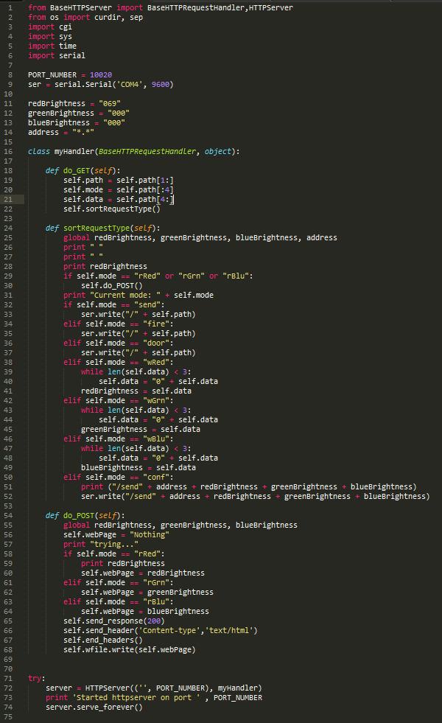

#### Software of Arduino Sender

The software on the Arduino Sender serves four different purposes, to read the RPi Serial input, to read button input, to process the input, and output that in the communication protocol that the infrastructure can understand using radio frequency. Here is the list of the order of events that occur:

1. Forever wait until the RPi attempts to send something
2. Once the RPi sends data through Serial, read what it says byte by byte.
3. Optional error checking could be done here, but the chance of an error produced by the communication of Serial is almost 1 in a million, so it would not be worth checking as the error will be picked up later in the data’s journey <>.
4. Barely any processing is done to the data packets on the Arduino Sender. The only thing that is added is an End Char at the end of the transmission to signal the end of transmission. This is a special invisible char that has an ASCII value of 2.
5. The Arduino Sender goes through byte by byte and displays that onto radio frequency waves.

The sent data packet is almost identical to the one the RPi passes to the Arduino sender, albeit the end character that consists of the special End Char character.

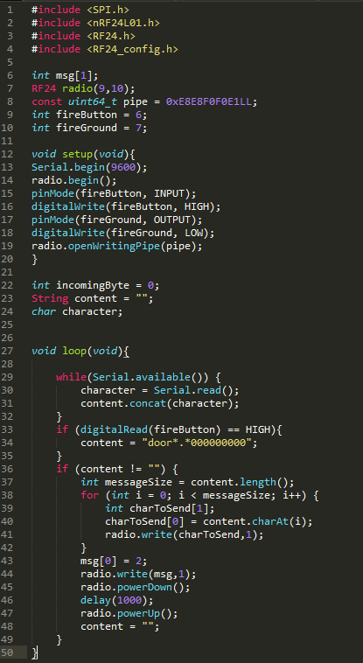

#### Software of Arduino Receiver



#### Software of Controller (Mobile Phone)

### Functions

#### Standard RGB Function

The standard

#### Fire Alarm Function

#### Door Bell Function

#### Timer Function

### Aesthetics

#### Aesthetics of Light Shell

#### Aesthetics of Physical Light Output

#### Aesthetics of Display

### Circuit Creation

#### Creation of Raspberry Pi Circuit

The creation of the RPi circuit relied heavily on each module being a success, otherwise none of the modules would function correctly. This circuit contains an Ethernet input, a microprocessor, and output to the sending Arduino.

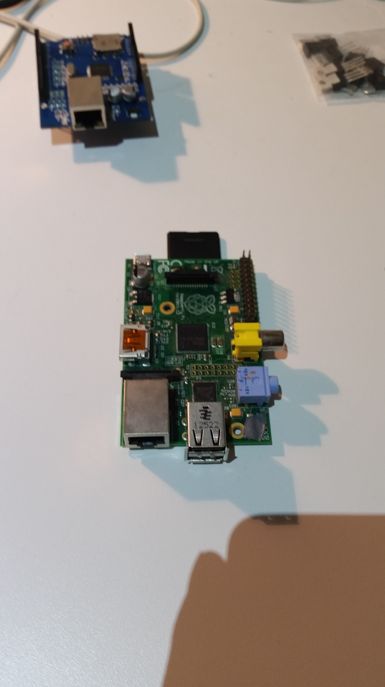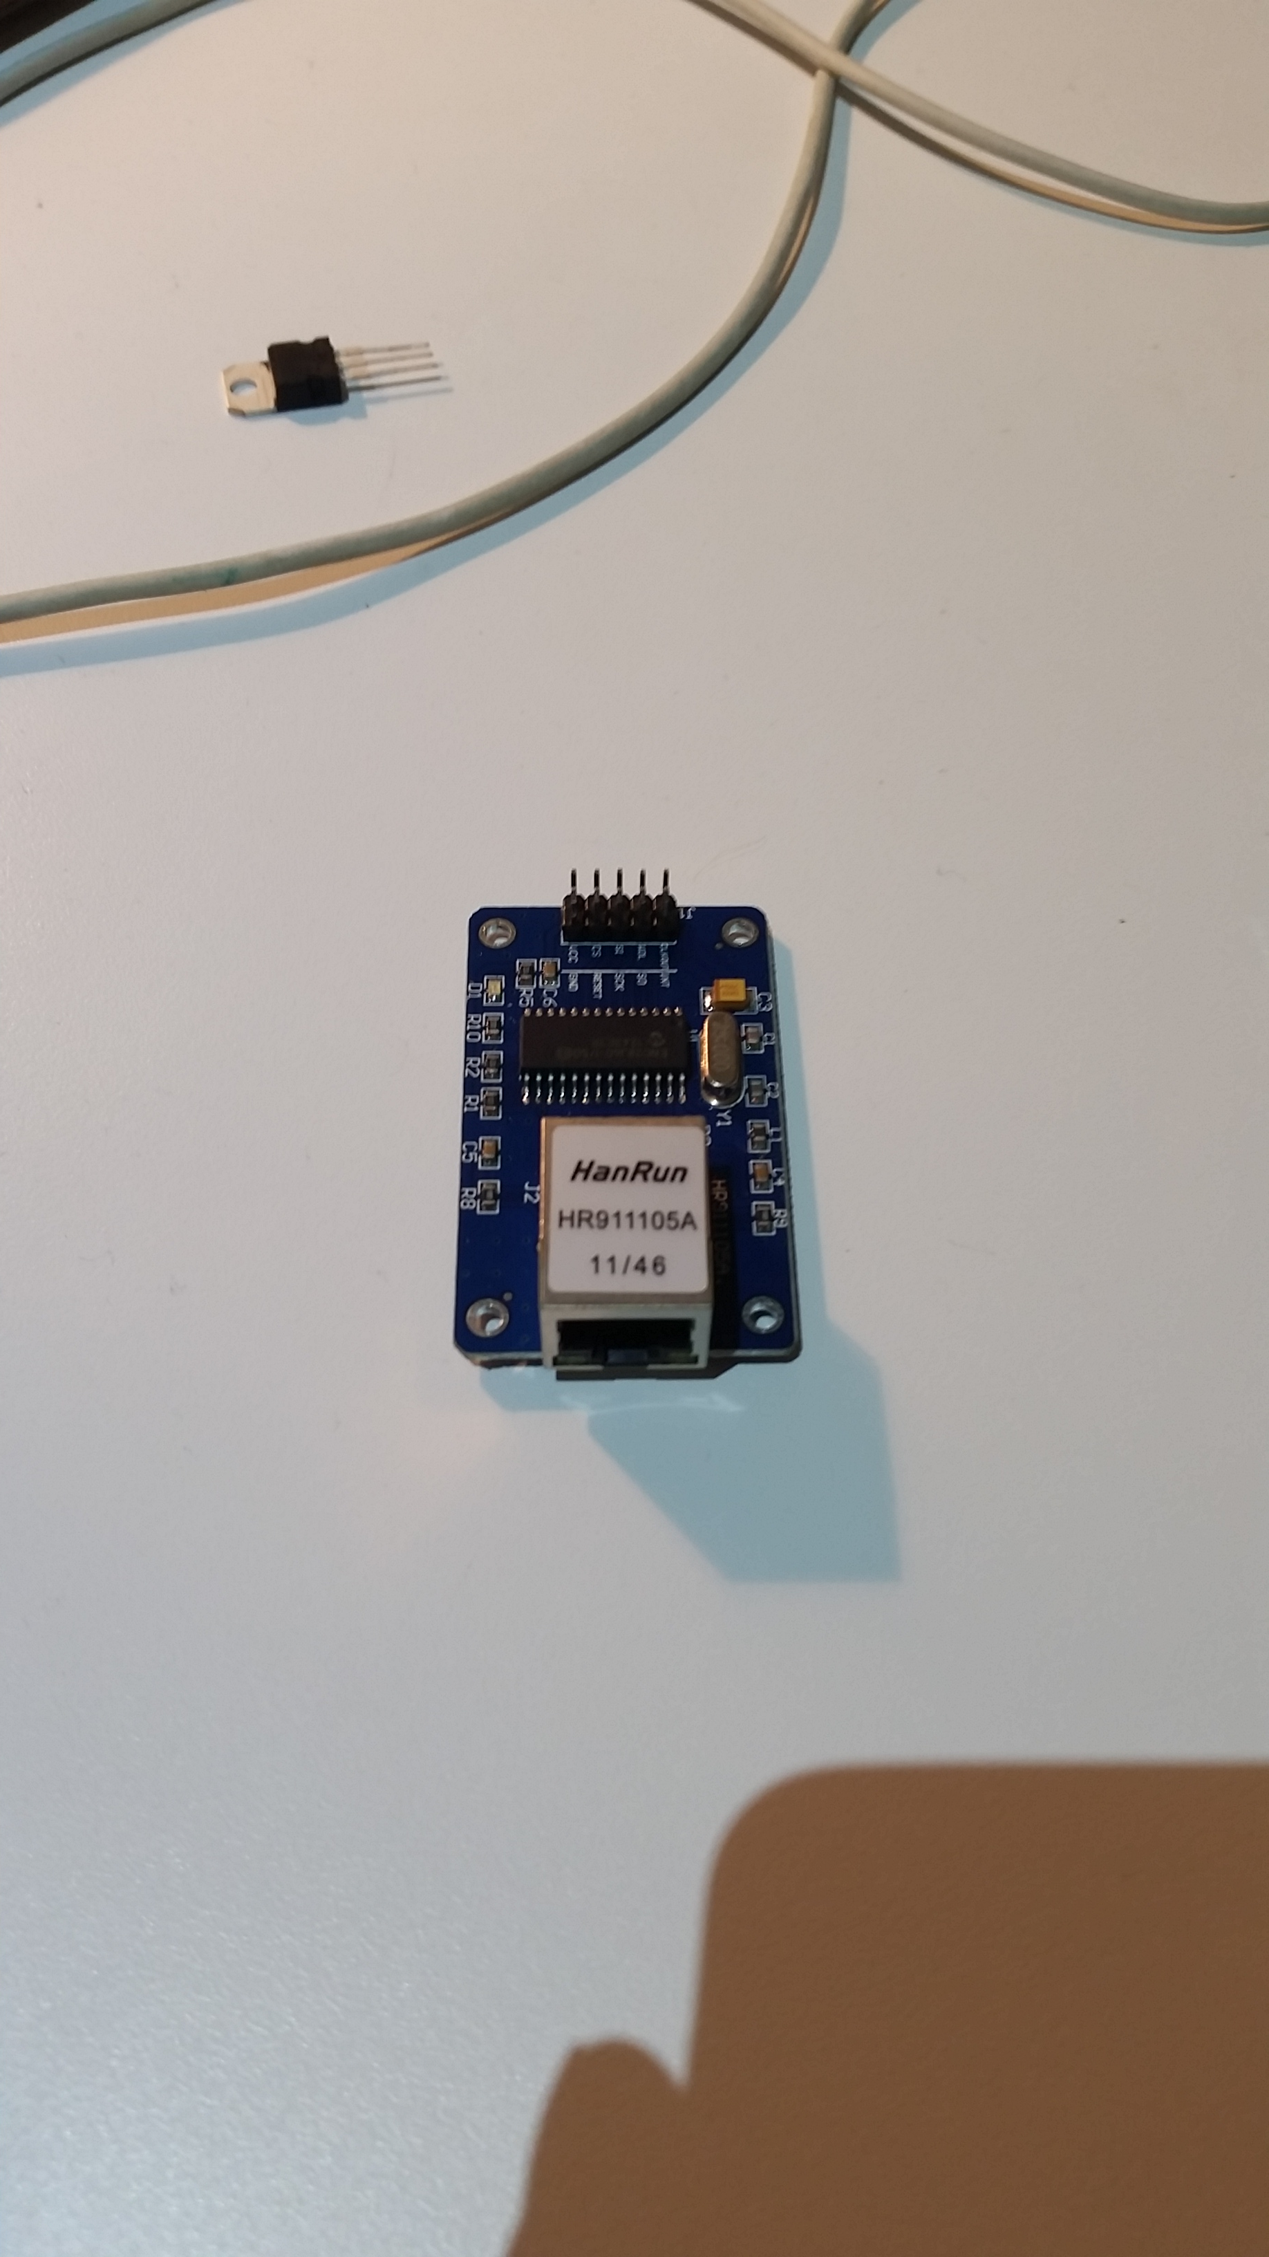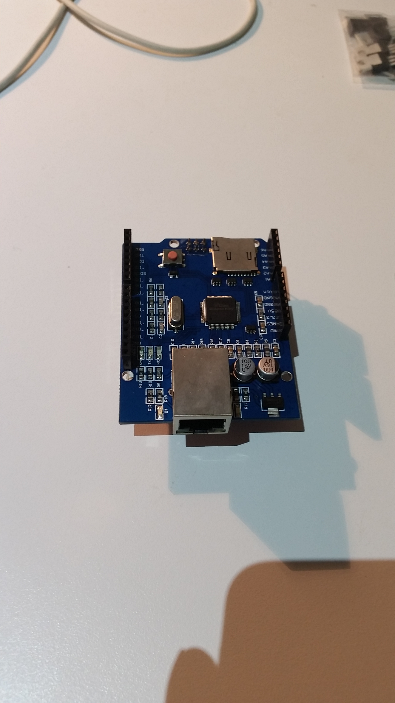

#### Creation of Arduino Sender Circuit

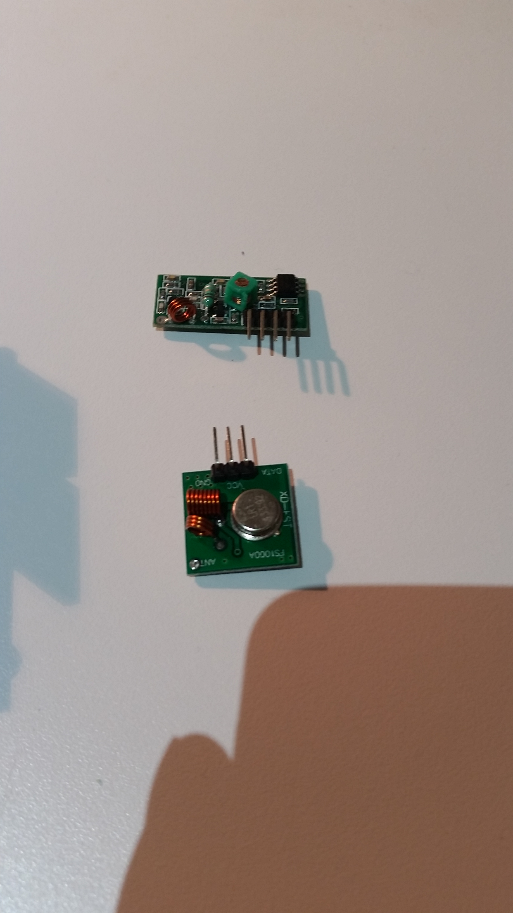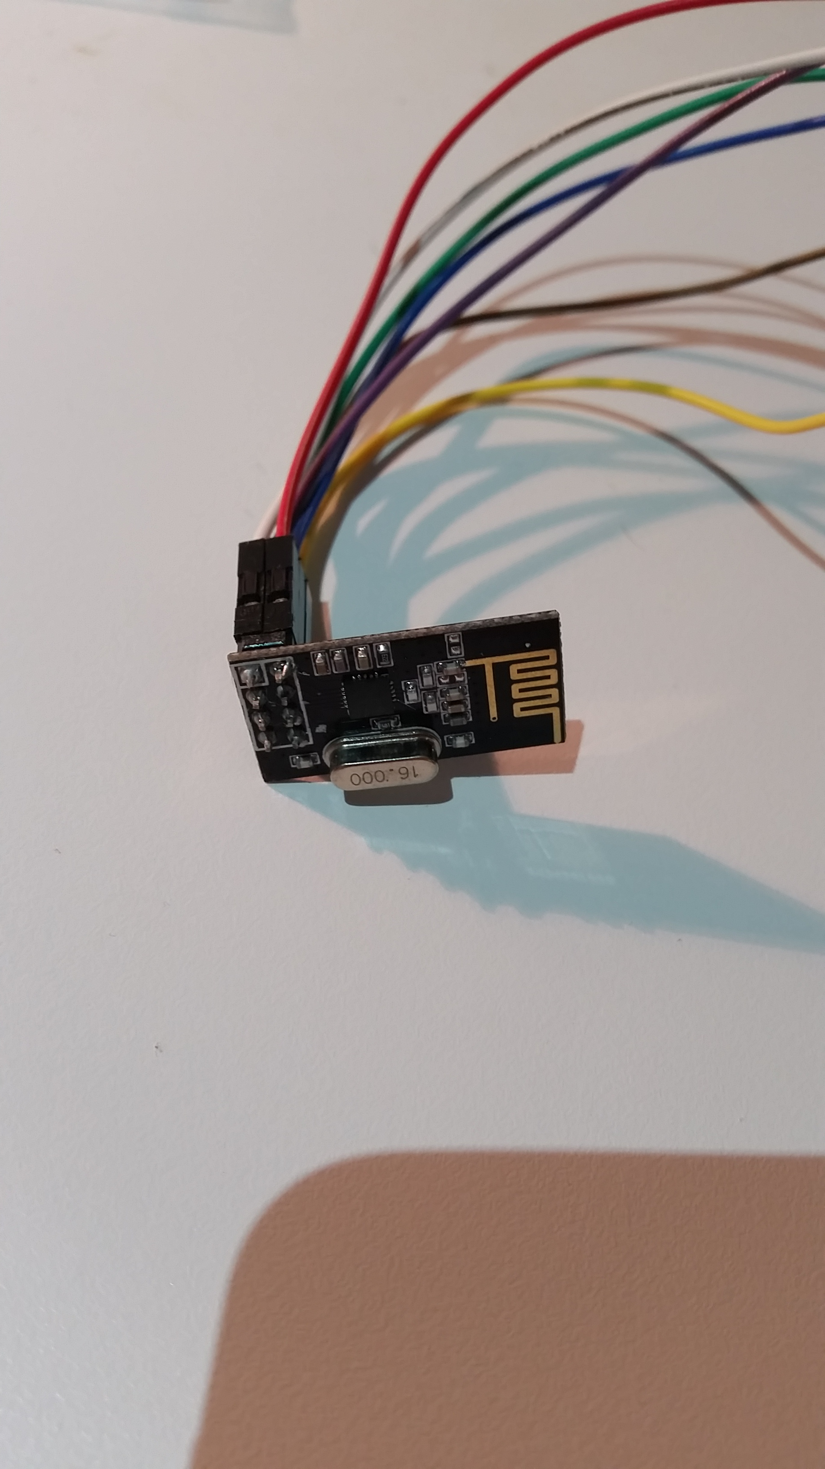

#### Creation of Arduino Receiver Circuit

##### Receiving Circuit



##### Processing Circuit

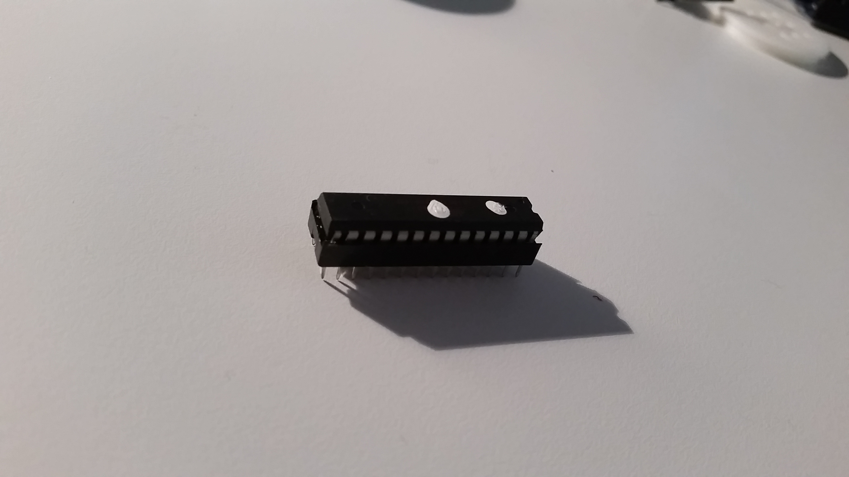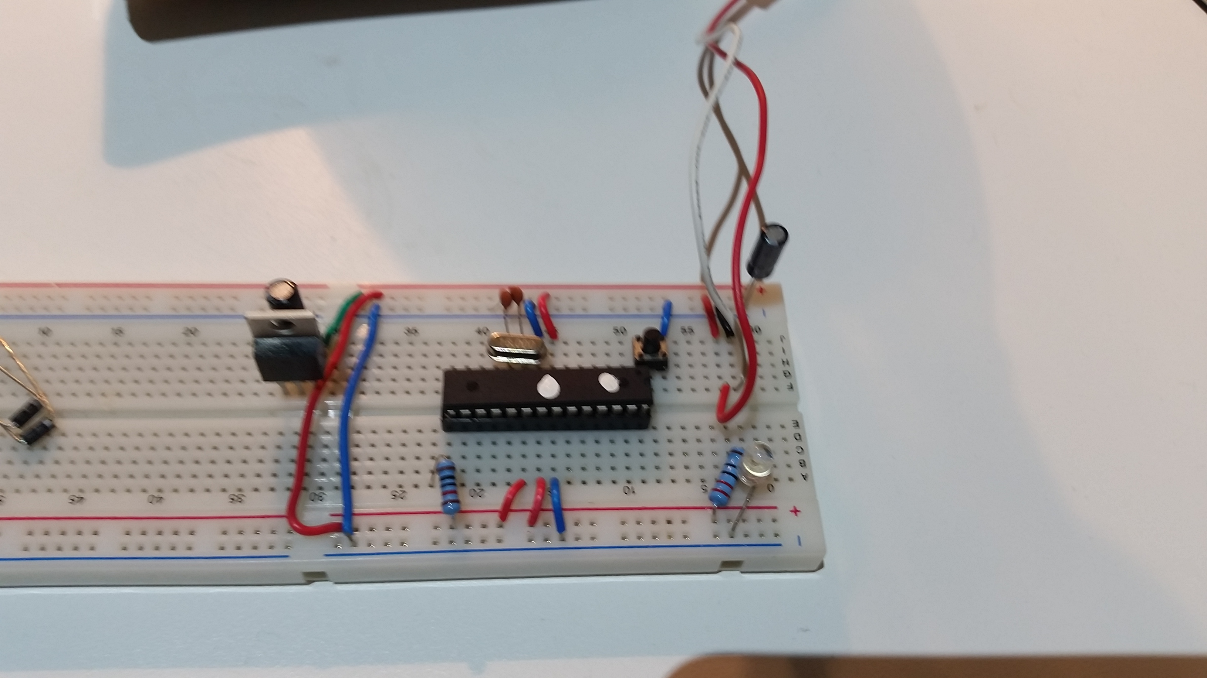

##### Output Circuit

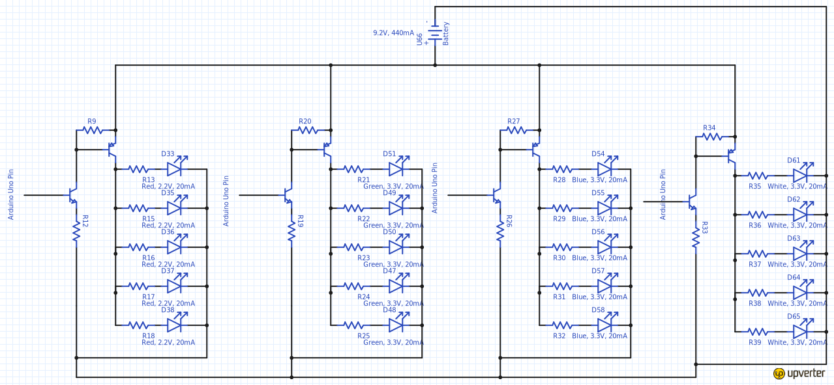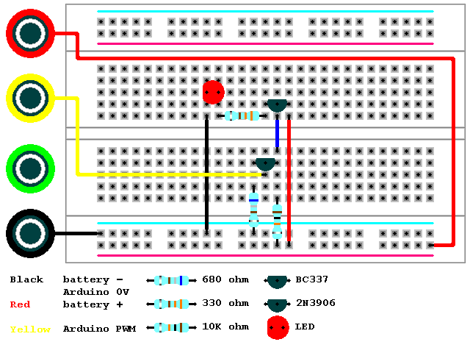

##### Aesthetics

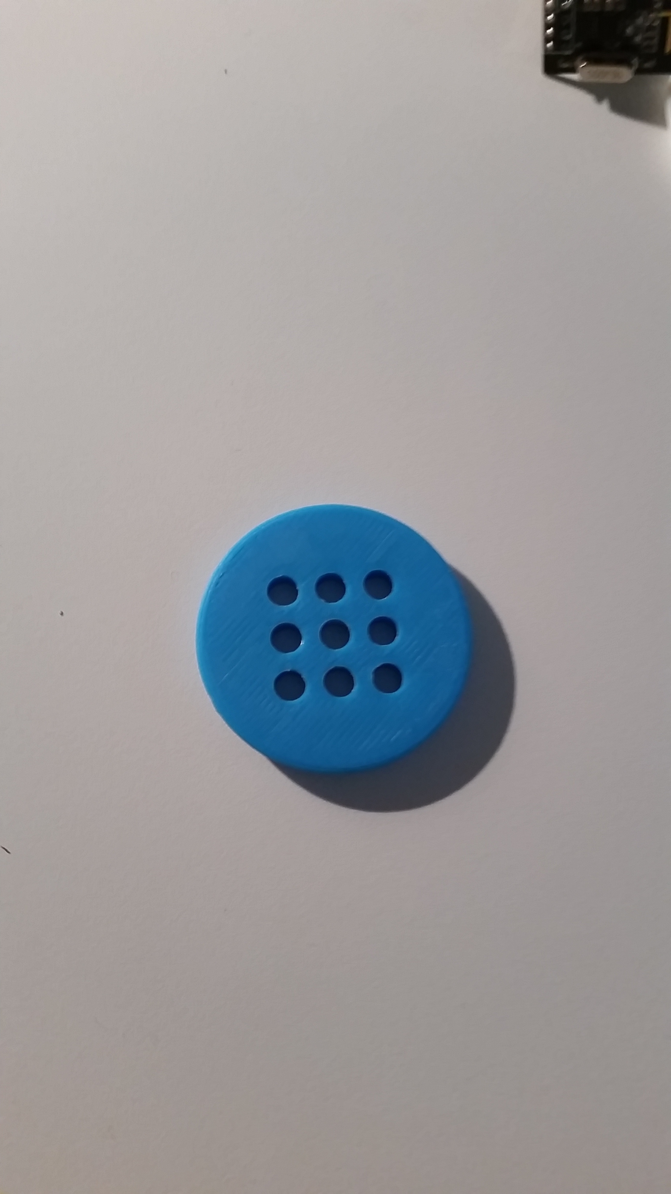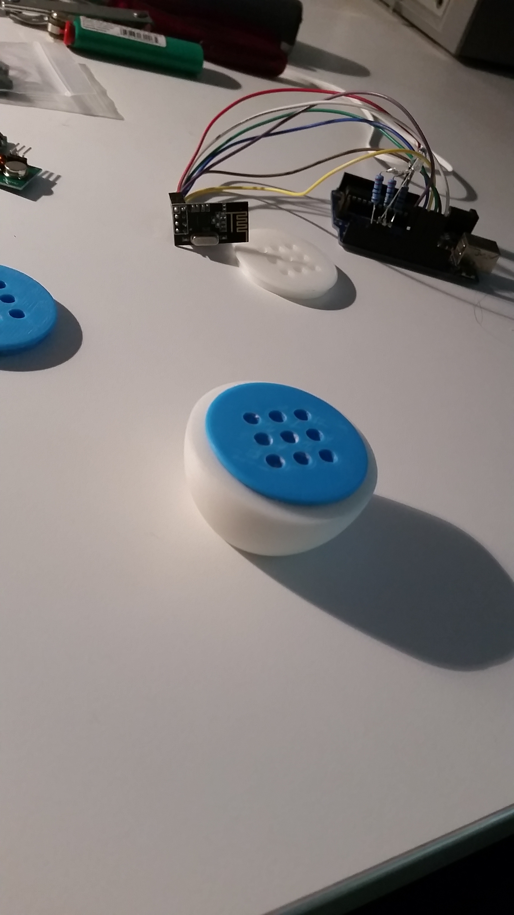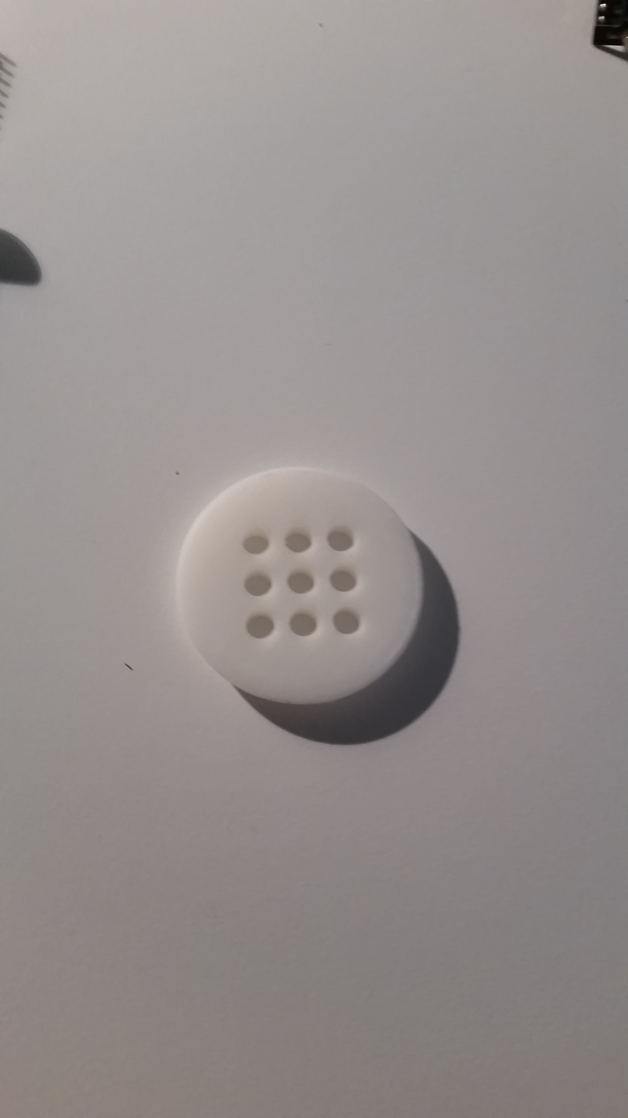

#### Creation of Final Microprocessor Circuit

## Degree of Difference

Do a spider web chart!

## Exploration of Existing Ideas

After finding this is exisiting idea which could act as a framework I decided to email to developer to see if it was possible to add a feature:

Me:  
“Hi there,   
I am currently creating a major project for my last year of school. Your app is what I am using for communication, but I was just wondering when the RGB colour picker will be released for the NetIO app, as it will make my project much more better. Is there any chance I could get a beta version of it, if it's already in development? (android)

If so,  thank you! If not I understand.

Regards,   
Lachlan Brown”

Developer:

“Hi Lachlan,

thanks for your mail. I saw you are already working on three sliders to set the color! The colorpicker is the next item we are going to implement. However, my brother who is developing the android app is on holidays for a few weeks now as he graduated a couple of days ago ;)

We can invite you to beta testing, however the colorpicker will come in september or october .. ( but not guaranteed!)

I suggest using sliders ( and make them coloured in red/green/blue) as I did in my living room (see attachment)

Best regards

David”

## Consideration of Design Factors Relevant to the Major Design

|  |  |  |
| --- | --- | --- |
| Factors Affecting Design |  |  |
| Factor | Description | How I have applied this factor |
| Function |  |  |
| Size Light |  |  |
| Luminosity of Light |  |  |
| Distance for Wireless Communication |  |  |
|  |  |  |
|  |  |  |

## Appropriate Research and Experimentation of Materials, Tools,

### Industrial vs School Based Production

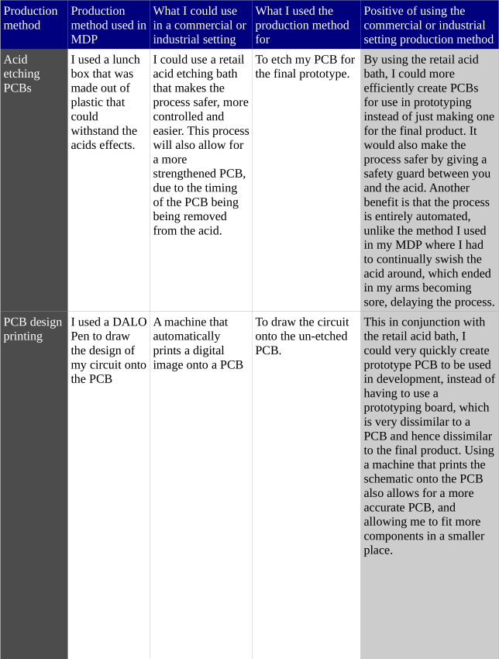

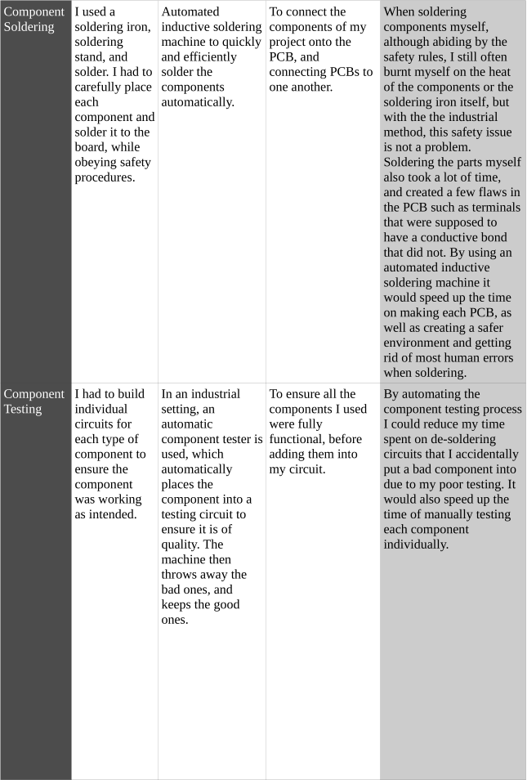

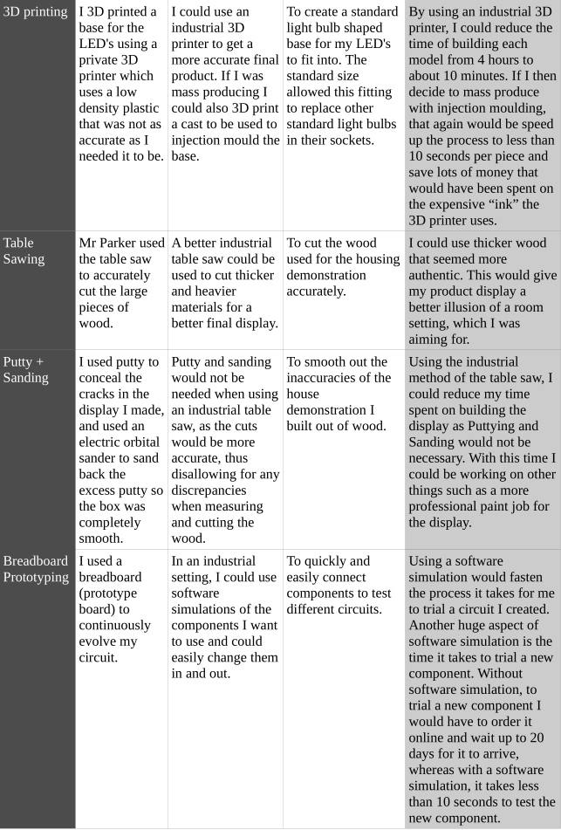

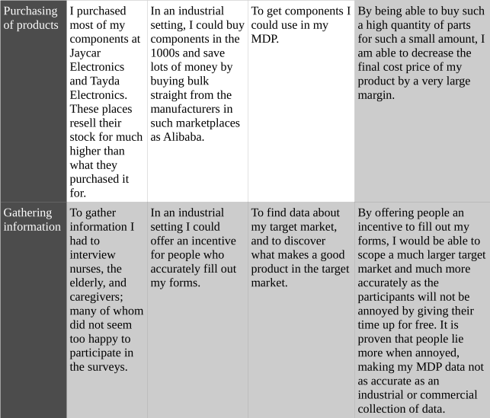

## Techniques and Testing of Design Solutions

### How I made the PCBs

I am making my own circuit boards for the project, so I need to know how to make them, and practice doing this.PCB is a component made out of layers of insulating materials with electrical conductors. The insulator can be made of many materials, mainly plastic, fibreglass and ceramics. During manufacture, the extra conductors that are not required, are etched off leaving a printed circuit where I can attach my electronic components.



Safety

* I am going to be using very corrosive chemicals and eye protection must be worn.
* If any acid gets on my skin/clothes rinse under water immediately.
* If any acid ends up in my eyes rinse under water immediately and seek medical help.

What materials/equipment are needed?

* Copper Clad Board
* Waterproof Permanent Marker
* Etching Acid (Ferric Chloride or Ammonia Persulphate)
* Drill
* Tinsnips
* Hacksaw
* Sandpaper (Emery Cloth, something not too rough)
* Bath for etching
* Multimeter

### Radio Frequency Device to Use

I had the choice of 2 different RF transceivers, the 433Mhz RF transmitter and receiver (which will be referred to as 433), and the Nrf24L01 transceiver (which will be referred to as Nrf) for the wireless communication method. The 433 consists of 1 transceiver and one receiver, whereas the Nrf consists of just one transceiver, where 2 is required for communication. To find out which one would best suit my product, I ran a few tests on each device:

#### Range Minimum Test

##### Aim

To test what the minimum distance is that the two different RF devices can communicate with data accuracy over 90%. This will allow me to know where to install the communication modules when installing the system.

##### Equipment

* 2 x Arduino Uno w/ Power Supplies
* 1 x LCD screen
* 1 x LED
* 1 x 433
* 2 x Nrf
* 1 x Push Button
* Various Wires
* Tape Measurer

##### Procedure

1. Write code for communicating test packets of data, and displaying accuracy on the LCD screen of the receiving Arduino. Pressing the push button will send 1 data packet from the sender to the reciever.
2. Set up the two Arduino’s at a set distance apart using the tape measure (I used 10m because of prior knowledge)
3. Press the push button
4. If the LCD is showing the accuracy is greater than 90%, half the current distance and go back to step 2. If the accuracy is less than 90% move the arduino’s back half the distance they were moved towards each other before.
5. After repeating steps 2, 3, 4 a definite distance will be found where the RF devices cannot communicate with a 90%+ accuracy
6. For a last check that the distance is right, a 10% check is used, where the arduino’s are setup 10% close than the perfect distance and tested. The accuracy should be below 90%. Then the arduino’s are setup 10% back from the perfect distance. The accuracy should be greater than 90%, or even equal. If these two conditions are not met, step 2, 3, 4 should be repeated more.

An example of this procedure with the 433 looked like:

* 433’s at 10m gave 95% accuracy
* Moved forward to 5m distance
* 433’s at 5m gave 94% accuracy
* Moved forward to 2.5m distance
* 433’s at 2.5m gave 94% accuracy
* Moved forward to 1.25m distance
* 433’s at 1.25m distance gave 88% accuracy
* Moved back to 2m distance
* 433’s at 2m distance gave 92% accuracy
* Moved forward to 1.5m distance
* 433’s at 1.5m distance gave 90% accuracy
* Moved back to 1.6m distance
* 433’s at 1.6m distance gave 91% accuracy
* Moved forward to 1.4m distance
* 433’s at 1.4m distance gave 89% accuracy

##### Safety

Going in to this experiment, I did not have many safety concerns other than the radiation RF transmitters give off. I combatted this safety concern by making sure I never had my head too close to the transmitter while it was on and sending data.

After going through the procedure, I accidentally cut myself on the tape measurer while winding it back up. This was careless of me, and through evaluation I have decided that it would be a good idea to take more care around the tape measurer and wear gloves when winding the tape back in from a distance greater than 5m.

##### Discussion

The procedure requires a bit of common sense to come to a conclusion where a definite answer is given, this is poor design if this procedure was made public. Another flaw in this experiment is the fact that one of the modules may have been broken and not working to its full potential. I combatted this by doing multiple test, each time using different hardware modules. A better way I could of done this test was to have multiple receivers that found the average between them, instead of relying on a single receiver.

##### Conclusion

I concluded that the 433’s minimum sending distance with an accuracy greater than 90% is 1.5m. This is a very large distance when compared to the conclusion of the Nrf’s minimum distance of 5cm. Although comparatively, the Nrf was much better than the 433, anything less than a minimum of 3m is needed for this product to be successful when installed correctly. So in all, the Nrf wins as it allows for human error when installing the modules if two modules are too close.

#### Range Maximum Test

##### Aim

To test what the maximum distance is that the two different RF devices can communicate with data accuracy over 90%. This will allow me to know what the maximum coverage distance is for each RF module and allow me to install the system to it’s fullest potential.

##### Equipment

* 2 x Arduino Uno w/ Power Supplies
* 1 x LCD screen
* 1 x 433
* 2 x Nrf
* 1 x Push Button
* Various Wires
* Tape Measurer

##### Procedure

1. Write code for communicating test packets of data, and displaying accuracy on the LCD screen of the receiving Arduino. Pressing the push button will send 1 data packet from the sender to the reciever.
2. Set up the two Arduino’s at a set distance apart using the tape measure (I used 15m because of prior knowledge)
3. Press the push button
4. If the LCD is showing the accuracy is greater than 90%, move the arudino’s back 5m. This step should be repeated until the accuracy is less than 90%.
5. By finding where the accuracy is 90%, a 10% distance check should be used. The arduino’s are setup 10% close than the perfect distance and tested. The accuracy should be above 90%. Then the arduino’s are setup 10% back from the perfect distance. The accuracy should be less than 90%. If these two conditions are not met, step 4 should be repeated more.

##### Safety

Going in to this experiment, I did not have many safety concerns other than the radiation RF transmitters give off. I combatted this safety concern by making sure I never had my head too close to the transmitter while it was on and sending data.

After going through the procedure, I accidentally cut myself on the tape measurer while winding it back up. This was careless of me, and through evaluation I have decided that it would be a good idea to take more care around the tape measurer and wear gloves when winding the tape back in from a distance greater than 5m.

##### Discussion

The procedure requires a bit of common sense to come to a conclusion where a definite answer is given, this is poor design if this procedure was made public. Another flaw in this experiment is the fact that one of the modules may have been broken and not working to its full potential. I combatted this by doing multiple test, each time using different hardware modules. A better way I could have done this test was to have multiple receivers that found the average between them, instead of relying on a single receiver.

##### Conclusion

I concluded that the 433’s maximum sending distance with an accuracy greater than 90% is 30m. This is a very small distance when compared to the conclusion of the Nrf’s maximum distance of 50m. To conclude, it would be very difficult to use the 433’s in my product as it would mean more sender modules would need to be positioned around a large house to get the house full coverage. With the 50m sending distance of the Nrf, it makes the product a lot simpler as 1 single sending module can be used to cover a circle with a diameter of 100m. The Nrf was much better than the 433.

#### Rate of Messages Received Test

##### Aim

To test how many data packets can be received using each RF module in a 10 second period. This will let me know how often the system can send light commands to output modules.

##### Equipment

* 2 x Arduino Uno w/ Power Supplies
* 1 x LCD screen
* 1 x 433
* 2 x Nrf
* 1 x Push Button
* Various Wires

##### Procedure

1. Write code for communicating test packets of data, and displaying packets received on the LCD screen of the receiving Arduino. Pressing the push button will send 1000 data packets from the sender to the receiver in the duration of 10 seconds evenly spaced out.
2. Space the Arduino’s out at a 10m distance
3. Press the button
4. Wait 10 seconds
5. Record the number on the LCD screen
6. Repeat steps 3, 4, 5 five times in total
7. Average the 5 recordings and this is the final score

##### Safety

Going in to this experiment, I did not have many safety concerns other than the radiation RF transmitters give off. I combatted this safety concern by making sure I never had my head too close to the transmitter while it was on and sending data.

##### Discussion

The procedure gives a very good representation of the how many messages can be sent across 10m to each RF module. A flaw in the design though is that one RF module may be better at the 10m mark than the other one. A way to combat this would be to test the rates at 5m, 10m, 20m, and 40m to get a more accurate reading.

##### Conclusion

I concluded that the Nrf was much better than the 433 in this test. The Nrf allowed for 50 data packets to be received per second, whereas the 433 only allowed 20 data packets per second. This is very good to know as it allows me to have the lights update much faster if the user wishes to manual scroll through the lights colours smoothly, whereas the 433 may not look as smooth.

#### Accuracy of Messages Received Test

##### Aim

To test how accurately the packets are received from a 10m distance. This will let me know to what extent I’ll need to include an error checking method such as a checksum.

##### Equipment

* 2 x Arduino Uno w/ Power Supplies
* 1 x LCD screen
* 1 x 433
* 2 x Nrf
* 1 x Push Button
* Various Wires

##### Procedure

1. Write code for communicating test packets of data. Pressing the push button will send data packets from the sender to the receiver for the duration of 100 seconds at a rate of 5 packets per second. The receiving Arduino knows what the data packets consist of and marks how many correct packages are sent and how many incorrect packages are sent.
2. Space the Arduino’s a distance of 10m
3. Push the button
4. Read the number off the LCD screen

##### Safety

Going in to this experiment, I did not have many safety concerns other than the radiation RF transmitters give off. I combatted this safety concern by making sure I never had my head too close to the transmitter while it was on and sending data.

##### Discussion

The procedure gives a very good representation of the how accurately messages can be sent across 10m to each RF module. A flaw in the design though is that one RF module may be better at the 10m mark than the other one. A way to combat this would be to test the accuracy at 5m, 10m, 20m, and 40m to get a more accurate reading.

##### Conclusion

To conclude, the 433 received 474 correct packages out of the 500 sent. This amounts to a 95% accuracy rate. The Nrf received 491 packets correctly out of the 500 sent. This amounts to 98% which is a much higher rate than the 433. I was hoping for 100% accuracy rate so I would not have to include an error checking method, but with such a high accuracy rate I can use a simple error checking method such as a checksum.

#### Power Consumption Test

##### Aim

To test how much power each of these RF modules consume. I need to know this for when I design a circuit that uses one of these modules.

##### Equipment

* 1 x Arduino Uno w/ Power Supplies
* 1 x 433
* 1 x Nrf
* Various Wires
* Multimetre

##### Procedure

1. Write code for communicating test packets of data. The packets will automatically be sending every 100ms.
2. Measure the voltage that the device is using by putting the Multimetre in parallel with it. Take the average reading over 10 seconds
3. Measure the amperes that the device is using by putting the Multimetre in series with it. Take the average reading over 10 seconds

##### Safety

Safety is very important when dealing with live currents in the way that I am here. It is very important to always double check there are no lose live wires and that the circuit does not exceed 9V in total, or 5A.

##### Discussion

At first the readings seemed to fluctuate a lot for me, this was due to my lack of knowledge of how to read volts. It is very important to put it in parallel otherwise damage can occur to both you and the Multimetre.

##### Conclusion

At 3.3v the 433 receiver used 8mA which is 33mW and the sender used 12mA at 3.3V, giving a total power consumption of 66mW. At 3.3v the Nrf receiver used 10mA and the sender used 18mA at 3.3V which is 92mW in total. The 433 is much better for power consumption, but at such a low consumption rate, power consumption does not need to be of concern.

|  |  |  |
| --- | --- | --- |
|  | 433Mhz RF transmitter and receiver  20140814_123142 | Nrf24L01  20140814_123147 |
| Price | $2 | $5 |
| Range Minimum | 1.5m | 5cm |
| Range Maximum | 30m | 50m |
| Rate of Messages Received | 20 per second | 50 per second |
| Accuracy of Messages Received | 95% | 97% |
| Power Consumption | 66mW | 92mW |
| Ease to interface | Easy | Hard |
| Special Hardware needed to interface | Null | SPI (Serial Peripheral Interface bus is a synchronous serial data link) |
| Approximate Life Span | 3 years | 10 years |
| Power Consumption | Low | Low |

From the table it seemed obvious to use the Nrf due to its maximum range, accuracy of messages received and the approximate life span.

### Ethernet Adapter Device to Use

I had 3 options of devices to use, each one with their own specialty.

|  |  |  |  |
| --- | --- | --- | --- |
| Device | Key (for reference later) | Pro’s | Con’s |
|  | * 1 | * Small * Cheap * Easy to interface with | * Slow * Low accuracy of receiving information * Hard to connect hardware wise * Low life span (2 years) |
| C:\Users\Lachlan\AppData\Local\Microsoft\Windows\INetCache\Content.Word\20140814_123137.jpg | * 2 | * Cheap * Fits on to an Arduino nicely * Does not use any digital pins on the Arduino (outputs) | * Uses SPI (RF transceivers use SPI too, and Arduino can only use 1 SPI device at a time) * Slow * Low life span (3 years) |
| C:\Users\Lachlan\AppData\Local\Microsoft\Windows\INetCache\Content.Word\20140814_123708.jpg | * 3 | * Fast * Built in processing * Incredibly high accuracy of information * Easier to program * Can incorporate more of the design into it | * Expensive * Don’t know the language needed to program * Uses a lot of power (compared to the other 2 devices) |

I conducted 3 tests on each of their devices and recorded the results to find which would best suit my project. Test 1 was an accuracy test where long data packets were sent for an extended amount of time. Test 2 was a speed test where many data packets were sent in a very fast series. Test 3 was a latency test where the devices were on standby for 4 hours then sent a data packet, the reaction time was recorded. Here are the results:

#### Accuracy Test

##### Aim

##### Equipment

##### Procedure

##### Safety

##### Discussion

##### Conclusion

#### Speed Test

##### Aim

##### Equipment

##### Procedure

##### Safety

##### Discussion

##### Conclusion

#### Latency Test

##### Aim

##### Equipment

##### Procedure

##### Safety

##### Discussion

##### Conclusion

|  |  |  |  |
| --- | --- | --- | --- |
| Device | Accuracy Test | Speed Test | Latency Test |
| 1 |  |  |  |
| 2 |  |  |  |
| 3 |  |  |  |
|  |  |  |  |

# Project evaluation

## Criteria for evaluation

## Analysis of evaluation

## Impact of the major design project on the individual, society and the environment.